Chapter 3

Blade Design

Ch3: blade design

3.1 Blade design:
Wind turbine design is the process of defining the form and specifications of a wind turbine to extract energy from the wind. A wind turbine installation consists of the necessary systems needed to capture the wind's energy, point the turbine into the wind, convert mechanical rotation into electrical power, and other systems to start, stop, and control the turbine.

3.1.1 Axis:

Wind turbines come in a variety of shapes and sizes, but can always be assigned to only one of two types depending on the orientation of the rotor blades, axis of rotation whether it was horizontal-axis wind turbines (HAWTs) or vertical-axis wind turbines (VAWTs).
Although most of the wind turbines you see today are HAWT, VAWTs are steadily increasing in popularity.

*Let us distinguish the basic differences between the two types and their distinct advantages over one another.

3.1.2 Horizontal-Axis Wind Turbines:

Horizontal-axis wind turbines or HAWTs are wind turbines whose axis of rotation is parallel to the ground. As long as the rotor blades are faced in the direction of the wind, the turbine can efficiently convert the wind’s kinetic energy to electrical energy.

Since wind direction is not constant, large HAWTs have a yaw adjustment mechanism that automatically positions the wind turbine head to face against the direction of the wind. This enables these turbines to maximize energy conversion efficiency.

3.1.3 Vertical-Axis Wind Turbines:

Vertical-Axis wind turbines (VAWTs) are a new breed. They have rotor blades that spin parallel to the ground, so that they can operate anywhere without having to account for the wind direction. This makes places with volatile wind directions to be great locations for VAWTs. Because of the axis orientation, the gearbox and generator can be placed near the ground, eliminating the need for a high tower.

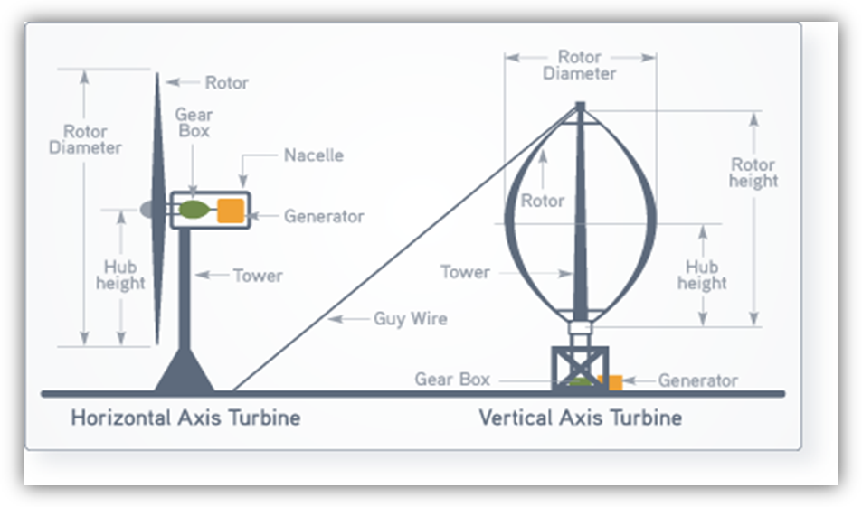

3.2 Darrieus wind turbine :

They have good efficiency, but produce large torque ripple and cyclical stress on the tower, which contributes to poor reliability. They also generally require some external power source, or an additional Savonius rotor to start turning, because the starting torque is very low. The torque ripple is reduced by using three or more blades which results in greater solidity of the rotor. Solidity is measured by blade area divided by the rotor area.

3.3 Giromill:
A subtype of Darrieus turbine with straight, as opposed to curved, blades. The cycloturbine variety has variable pitch to reduce the torque pulsation and is self-starting. The advantages of variable pitch are: high starting torque; a wide, relatively flat torque curve; a lower blade speed ratio; a higher coefficient of performance; more efficient operation in turbulent winds; and a lower blade speed ratio which lowers blade bending stresses. Straight, V, or curved blades may be used.

3.4 Savonius wind turbine :
These are drag-type devices with two (or more) scoops that are used in anemometers, Flettnervents (commonly seen on bus and van roofs), and in some high-reliability low-efficiency power turbines. They are always self-starting if there are at least three scoops.

3.5 Differences between VAWT & HAWT :

3.5.1 Installation:

Since VAWTs can have rotor blades close to the ground, they are easier to install compared to HAWTs that often require the rotor blades to be at a high altitude depending on the blade length.

3.5.2 Coefficient of wind power use :

Theoretically proved that the coefficient of wind power use of ideal wind rotor (wheel) of any wind turbine (both HAWT and VAWT) is 0.593. It can be explained by the fact that rotors of both turbine types use the same effect of lifting force appearing when the wind is flowing around the profiled blade. The maximum coefficient of wind energy use on HAWT has reached 0.4 recently.

3.5.3 START OF OPERATING (SELF START) :

It is considered that starting torque of propeller doesn’t equal to 0 (zero), no outside power source is needed. However practice shows that the HAWT rotor self-starts when it is enough directed on the wind
For a long time it was considered that starting torque of VAWT is equal to 0. I.e. it was considered that they are not self-starting. However the scientists of SRC-Vertical developed Darrieus rotor which self-starts on 3.5-4 m/sec wind speed. The self-starting torque of these turbines is much higher than 0. Moreover these turbines start from even small wind gust.

3.5.4 RATIONALITY OF POWER STRUCTURE OF WIND TURBINE :

Inertial loading on blade of the HAWT is applied along the blade, i.e. by the most disadvantageous way. Hub and support-bearing module are compact and small.
Inertial loading on the blade of VAWT is directed across the blade, along traverse. Hub and bearing module have relatively big size.

3.6 DESIGN OF BLADE:
All cross-sections of HAWT propeller are operating in different energy status because they have different rotating speeds and angles of attack. This difference is much less if the cross-sections are rolled relatively each other. Inertial loading leads to the necessity of narrowing the profile from butt to the end.

3.6.1 SWEPT AREA ON THE UNIT OF BLADE LENGTH :

The swept area of HAWT is the area of circle made by rotating blade ends. For VAWT this area equals the area of rectangle with the sides equal to length of blade and diameter of Wind Turbine (wind rotor or wheel). I.e. the swept area of VAWT is more flexible than of HAWT as it can be adjusted (or changed) by the dimensions not only of blade length, but also by diameter of Turbine, which makes the tactic possibilities of Turbine design wider.

3.6.2 HIGH-SPEED DEGREE:

The most widely distributed turbines among the propeller HAWTs, are the high-speed turbines (up to 5-7 modules), with less than 4 blades.

Vertical Axis Wind Turbines do not have such problems as their design provides low speed operation. In all known experiments including the search of maximum efficiency of wind use, the high-speed didn’t increase 2.5 – 2.8 modules

3.6.3 Maintenance:

For the same reason as above, VAWTs are easier to maintain since most of them are installed near the ground.
HAWTs should also be checked constantly so that it faces against the wind, unlike VAWTs which require less maintenance. Automatic yaw-adjustment mechanisms have eliminated this need of constant maintenance on HAWTs though

3.6.4 Recommendations:
It wouldn’t really make much of a difference since home wind turbines are just supplemental energy generators and aren’t really
needed to supply the primary energy requirements.

3.7 Advantages & Disadvantages

3.7.1 Advantages of vertical wind turbines
Easier to maintain because most of their moving parts are located near the ground. This is due to the vertical wind turbine’s shape. The airfoils or rotor blades are connected by arms to a shaft that sits on a bearing and drives a generator below, usually by first connecting to a gearbox. As the rotor blades are vertical, a yaw device is not needed, reducing the need for this bearing and its cost.
Vertical wind turbines have a higher airfoil pitch angle, giving improved aerodynamics while decreasing drag at low and high pressures. Mesas, hilltops, ridgelines and passes can have higher and more powerful winds near the ground than up high because of the speed up effect of winds moving up a slope or funneling into a pass combining with the winds moving directly into the site. In these places, VAWTs placed close to the ground can produce more power than HAWTs placed higher up.
Low height useful where laws do not permit structures to be placed high. Smaller VAWTs can be much easier to transport and install.
Does not need a free standing tower so is much less expensive and stronger in high winds that are close to the ground. Usually have a lower Tip-Speed ratio so less likely to break in high winds.

3.7.2 Disadvantages of vertical wind turbines
Most VAWTs produce energy at only 50% of the efficiency of HAWTs in large part because of the additional drag that they have as their blades rotate into the wind. This can be overcome by using structures to funnel more and align the wind into the rotor (e.g. "stators" on early Windstar turbines) or the "vortex" effect of placing straight bladed VAWTs closely together.
There may be a height limitation to how tall a vertical wind turbine can be built and how much sweep area it can have.
Most VAWTS need to be installed on a relatively flat piece of land and some sites could be too steep for them but are still usable by HAWTs.

Most VAWTs have low starting torque.
A VAWT that uses guyed wires to hold it in place puts stress on the bottom bearing as all the weight of the rotor is on the bearing. Guyed wires attached to the top bearing increase downward thrust in wind gusts. Solving this problem requires a superstructure to hold a top bearing in place to eliminate the downward thrusts of gust events in guyed wired models.

3.7.3 Advantages of horizontal wind turbines
Blades are to the side of the turbine's center of gravity, helping stability.
Ability to wing warp, which gives the turbine blades the best angle of attack. Allowing the angle of attack to be remotely adjusted gives greater control, so the turbine collects the maximum amount of wind energy for the time of day and season.
Ability to pitch the rotor blades in a storm, to minimize damage.
Tall tower allows access to stronger wind in sites with wind shear. In some wind shear sites, every ten meters up, the wind speed can increase by 20% and the power output by 34%.
Tall tower allows placement on uneven land or in offshore locations. Can be sited in forests above the treeline.
Most are self-starting.
Can be cheaper because of higher production volume, larger sizes and, in general higher capacity factors and efficiencies.

3.7.4 Disadvantages of horizontal wind turbines
HAWTs have difficulty operating in near ground, turbulent winds because their yaw and blade bearing need smoother, more laminar wind flows.
The tall towers and long blades (up to 180 feet long) are difficult to transport on the sea and on land. Transportation can now cost 20% of equipment costs. Tall HAWTs are difficult to install, needing very tall and expensive cranes and skilled operators.
Supply of HAWTs is less than demand and between 2004 and 2006, turbine prices increased up to 60%. At the end of 2006, all major manufacturers were booked up with orders through 2008. The FAA has raised concerns about tall HAWTs effects on radar in proximity to air force bases. Their height can create local opposition based on impacts to view sheds.

3.8 Why did we select HAWT in our project??

It has been tested time and time again that HAWTs are the more efficient wind turbines.
And since in our project we concentrate on the wind speed and the area study, high wind speeds can be gathered in our project producing an electrical power.
So we chose the horizontal axis wind turbine to be applied in our project.

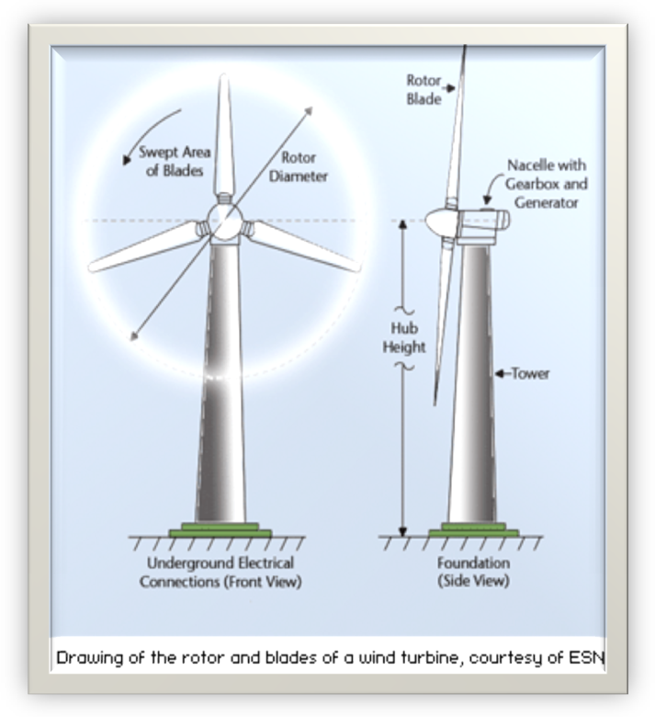
3.9 Number of blades:
The determination of the number of blades involves design considerations of aerodynamic efficiency, component costs, system reliability and aesthetics.

Noise emissions are affected by the location of the blades upwind or downwind of the tower and the speed of the rotor. Given that the noise emissions from the blades' trailing edges and tips vary by the 5th power of blade speed, a small increase in tip speed can make a large difference.

Aerodynamic efficiency increases with number of blades but with diminishing return. Increasing the number of blades from one to two yields a six percent increase in aerodynamic efficiency, where as increasing the blade count from two to three yields only an additional three percent in efficiency. Further increasing the blade count yields minimal improvements in aerodynamic efficiency and sacrifices too much in blade stiffness as the blades become thinner.

In addition, the fewer the number of blades, the higher the rotational speed can be. This is because blade stiffness requirements to avoid interference with the tower limit how thin the blades can be manufactured, but only for upwind machines; deflection of blades in a downwind machine results in increased tower clearance. Fewer blades with higher rotational speeds reduce peak torques in the drive train, resulting in lower gearbox and generator costs.

3.9.1 Advantages of 5-blade wind turbines over 3-blade wind turbines:
1) 5-blade wind turbines will greatly improve annual energy production in low wind conditions. For areas with average wind speeds of 11 MPH (5m/s) If you compare annual energy output to conventional 3-blade wind turbine, there is an increase of annual energy output of more than 60%.
2) 5-blade wind turbines will dramatically improve the reliability and safety in high speed wind conditions. The blade rotation speed of a 5-blade turbine is 60% of the rotational speed for a 3-blade wind turbine. 5-blade wind turbines will greatly reduce chance of over speed control malfunction. This will ensure operational reliability from a long term perspective.
3) The lower blade rotation speed of 5-blade wind turbine will lower wind turbine noise and make 5-blade wind turbines more community friendly than 3-blade wind turbines generating efficiency.

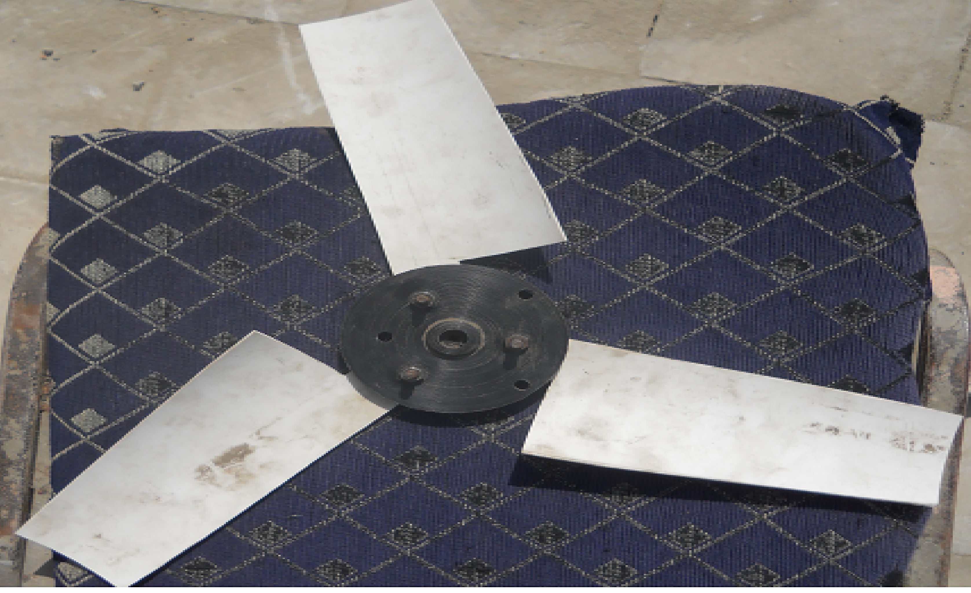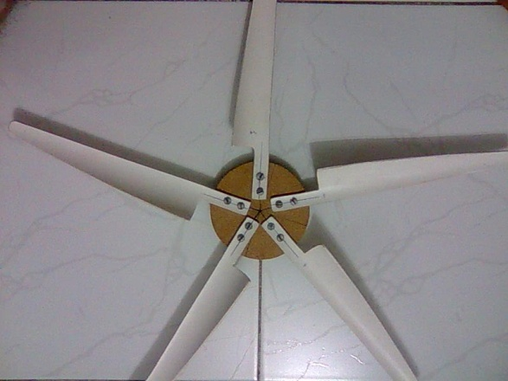

3.9.2 Blade materials:
Choosing your blade material is one of the most important steps in your blade design as it affects on your speed of rotation and the torque produced.
In small homemade wind turbines we deal with Small blades which can be made from light materials such as Fiberglass, Aluminum, Wood and PVC.
3.10 Wind turbine blades material:
- Wood blades:
Easy to make but also easy to be destroyed. Wood blades are usually used in some simple and small wind turbines. Good wood may increase the lifetime of the blades.
- PVC blades:
PVC blades have the light weight and easy to install but it is only applied in small wind turbines.
- Aluminum alloy blades:
It is not unusual blades material for small wind turbines. In some countries, aluminum alloy blades are used for 1kw-5kw wind turbines.
- Fiber Glass blades:
It is the popular wind turbine blades material for both small wind turbines and large wind turbines. The problem is that it is difficult to make for home or small factory. It needs the professional technology and equipments.

3.11 Wind turbine aerodynamics:
The primary application of wind turbines is to extract energy from the wind. Hence, the aerodynamics is a very important aspect of wind turbines. Like many machines, there are many different types all based on different energy extraction concepts. Similarly, the aerodynamics of one wind turbine to the next can be very different.
Overall the details of the aerodynamics depend very much on the topology. There are still some fundamental concepts that apply to all turbines. Every topology has a maximum power for a given flow, and some topologies are better than others. The method used to extract power has a strong influence on this. In general all turbines can be grouped as being lift based, or drag based with the former being more efficient. The difference between these groups is the aerodynamic force that is used to extract the energy.
The most common topology is the Horizontal Axis Wind Turbine. It is a lift based wind turbine with very good performance, accordingly it is a popular for commercial applications and much research has been applied to this turbine.

3.12 General Aerodynamic Considerations:
The governing equation for power extraction is given below:
(1)
Where: P is the power, F is the force vector, and U is the speed of the moving wind turbine part.
The force F is generated by the wind interacting with the blade. The primary focus of wind turbine aerodynamics is the magnitude and distribution of this force. The most familiar type of aerodynamic force is Drag; this is the same force that is felt pushing against you on a windy day. Another type of force is lift; this is the same force that allows most aircraft to fly. The direction of the drag force is parallel to the relative wind, while the lift force is perpendicular. Typically, the wind turbine parts are moving so this alters the flow around the part. An example of relative wind is the wind one would feel cycling on a calm day.
To extract power, the turbine part must move in the direction of the force. In the drag force case, the relative wind speed decreases subsequently so does the drag force. The relative wind aspect dramatically limits the maximum power that can be extracted by a drag based wind turbine. Lift based wind turbine typically have lifting surfaces moving perpendicular to the flow. Here, the relative wind will not decrease in fact it increases with rotor speed. Thus the maximum power limit of these machines is much higher than drag based machines.

3.13 Typical Parameters used to characterize wind turbines:
Different wind turbines will come in different sizes. Then once the wind turbine is operating it will experience a wide range of conditions. This variability complicates the comparison of different types of turbines. To deal with this, non dimensionalization is applied to various qualities. One of the qualities of nondimensionalization is that when geometrically similar turbines will produce the same non-dimensional results, while because of other factors (difference in scale, wind properties) produce very different dimensional properties. This allows one to make comparisons between different turbines, while eliminating the effect of things like size and wind conditions from the comparison.
The coefficient of power is the most important variable in wind turbine aerodynamics. Buckingham π theorem can be applied to show that non-dimensional variable for power is given by the equation below. This equation is similar to efficiency, so values between 0 and less than one are typical. However this is not the exactly the same as efficiency so in practice some turbines can exhibit greater than unity power coefficients. In these circumstances one cannot conclude the first law of thermodynamics is violated because this is not an efficiency term by the strict definition of efficiency.
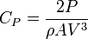 (Cp)
Where: CP is the coefficient of power, ρ is the air density, A is the area of the wind turbine, finally V is the wind speed.
Equation (1) shows two important dependents. The first is the speed that the machine is going (U). This variable is nondimensionalized by the wind speed, to get the speed ratio:

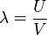 (Speed ratio)
The force vector is not straightforward, as stated earlier there are two types of aerodynamic forces, lift and drag. Accordingly there are two non-dimensional parameters. However both variables are non-dimensionalized in a similar way. The formula for lift is given below; the formula for drag is given after:
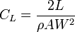 (CL)
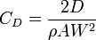 (CD)
Where: CL is the lift coefficient, CD is the drag coefficient, W is the relative wind as experienced by the wind turbine blade, A is the area but may not be the same area used in the power non-dimensionalization of power.
The aerodynamic forces have a dependency on W, this speed is the relative speed and it is given by the equation below. Note that this is vector subtraction.
(Relative speed)

3.13.1 Maximum power of a drag based wind turbine:
Equation (1) will be the starting point in this derivation. Equation (CD) is used to define the force, and equation (Relative Speed) is used for the relative speed. These substitutions give the following formula for power.
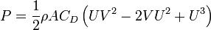 (Drag power)
The formulas (CP) and (SpeedRatio) are applied to express (DragPower) in nondimensional form:
(Drag Cp)
It can be shown through calculus that equation (Drag CP) achieves a maximum at λ = 1 / 3. By inspection one can see that equation (DragPower) will achieve larger values for λ > 1. In these circumstances, the scalar product in equation (1) makes the result negative. Thus, one can conclude that the maximum power is given by:
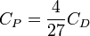
Experimentally it has been determined that a large CD is 1.2, thus the maximum CP is approximately 0.1778.
3.13.2 Maximum power of a lift based wind turbine:
The derivation for the maximum power of a lift based machine is similar, with some modifications. First we must recognize that drag is always present, thus cannot be ignored. It will be shown that neglecting drag leads to a final solution of infinite power. This result is clearly invalid; hence we will proceed with drag. As before, equations (1), (CD) and (Relative Speed) will be used along with (CL) to define the power below expression
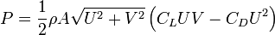 (Lift power)
Similarly, this is non-dimensionalized with equations (CP) and (Speed Ratio). However in this derivation the parameter γ = CD / CL are also used:
(Lift Cp)

γ | Optimal λ | Optimal C_{P}
0.5 | 1.23 | 0.75 CL
0.2 | 3.29 | 3.87 CL
0.1 | 6.64 | 14.98 CL
0.05 | 13.32 | 59.43 CL
0.04 | 16.66 | 92.76 CL
0.03 | 22.2 | 164.78 CL
0.02 | 33.3 | 370.54 CL
Experiments have shown that it is not unreasonable to achieve a drag ratio (γ) of approximately 0.01 at a lift coefficient of 0.6. This would give a CP of about 889. This is substantially better than the best drag based machine, hence why lift based machines are superior.
In the analysis given here, there is an inconsistency compared to typical wind turbine non-dimensionalization. As stated in the preceding section the A in the CP non-dimensionalization is not always the same as the A in the force equations (CL) and (CD). Typically for CP the A is the area swept by the rotor blade in its motion. For CL and CD A is the area of the turbine wing section. For drag based machines, these two areas are almost identical so there is little difference.
To make the lift based results comparable to the drag results, the area of the wing section was used to non-dimensionalize power. The results here could be interpreted as power per unit of material. Given that the material represents the cost (wind is free), this is a better variable for comparison.
If one were to apply conventional non-dimensionalization, more information on the motion of the blade would be required. However the discussion on Horizontal Axis Wind Turbines will show that the maximum CP there is 16/27. Thus, even by conventional non-dimensional analysis lift based machines are superior to drag based machines.

3.14 Horizontal Axis Wind Turbine Aerodynamics:

The wind turbine aerodynamics of a horizontal-axis wind turbine (HAWT) is not straightforward. The air flow at the blades is not the same as the airflow further away from the turbine. The very nature of the way in which energy is extracted from the air also causes air to be deflected by the turbine. In addition the aerodynamics of a wind turbine at the rotor surface exhibit phenomena that are rarely seen in other aerodynamic

